Govt. High School
Sindhi Jamaat Co-Operative Housing Society, Karachi
REPORT ON PARENT-TEACHER MEETINGS – MAY 2025
Total Strength: 100 |  | Class: Level-II & III
Attendants: 58 |  | Date: 3-5-2025
 |  | Time: 9:00 AM to 12:00 PM

1. Introduction
Parent-Teacher Meetings (PTMs) were successfully conducted for Level 2 and Level 3 classes to review student progress, classroom performance, and overall development. The meetings aimed to strengthen collaboration between parents and teachers and ensure mutual efforts in nurturing students’ academic and personal growth.

2. Objective
- To discuss individual student’s academic progress.
- To highlight classroom activities and student engagement.
- To review copy maintenance and notebook organization.
- To guide parents regarding summer vacation homework.
- To promote consistent communication between parents and teachers.
3. Attendance Overview
Class Level | Total Parents | Parents Attended | Attendance %
Level 2 | 52 | 28 | 54%
Level 3 | 48 | 30 | 62%

4. Meeting Agenda Highlights
- Class Progress: Evaluation of academic performance and areas for improvement.
- Activities: Discussion of recent and upcoming class activities and their impact on learning.
- Copy Maintenance: Monitoring the completeness and neatness of students' notebooks.
- Summer Vacation Homework: Instructions given regarding assigned work during the break.

5. Observations
- Most parents appreciated the opportunity to discuss their child’s performance individually.
- Parents expressed satisfaction with classroom learning and school environment.
- Teachers noted that parental involvement positively impacts student behavior and consistency.
- A few parents requested regular updates about homework and upcoming assessments.

6. Recommendations
- Continue periodic PTMs for consistent parent-school communication.
- Encourage parents to regularly check student notebooks and homework.
- Share updates via class groups or communication diaries to improve transparency.
- Provide early notice of vacation homework and upcoming school activities.

7. Conclusion
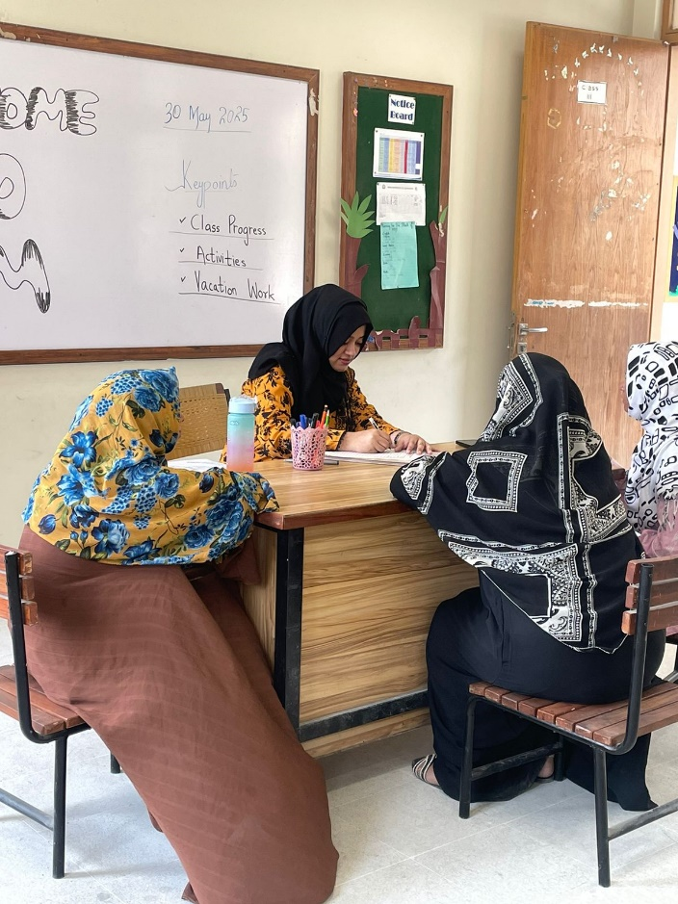
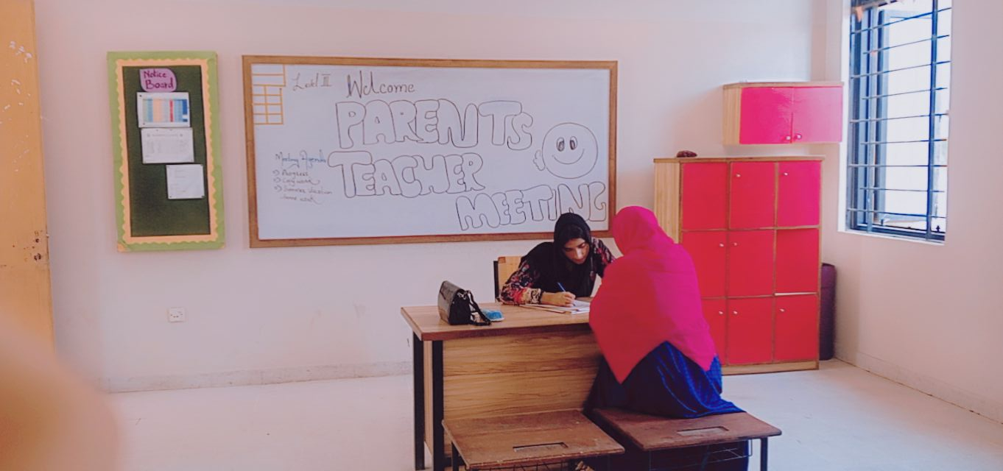
The Parent-Teacher Meetings for Level 2 and Level 3 were productive and well-received. They played a vital role in reviewing student performance and setting clear expectations for the upcoming term. The active participation of parents reflects a growing culture of collaboration and shared responsibility in the education journey of students.

